006CPJ744 - K P SHRINIVASH
Day 8 - 27th July 2026

Jdk 18 and above

java -version
java version "26.0.2" 2026-07-21
Java(TM) SE Runtime Environment (build 26.0.2+10-55)
Java HotSpot(TM) 64-Bit Server VM (build 26.0.2+10-55, mixed mode, sharing)

mvn -v
Apache Maven 3.9.6 (bc0240f3c744dd6b6ec2920b3cd08dcc295161ae)
Maven home: C:\Program Files\apache-maven-3.9.6
Java version: 17.0.12, vendor: Oracle Corporation, runtime: C:\Program Files\Java\jdk-17
Default locale: en_IN, platform encoding: Cp1252
OS name: "windows 11", version: "10.0", arch: "amd64", family: "windows"

>mvn archetype:generate -DgroupId=com.bank -DartifactId=Demo02_DependencyInjection -DarchetypeArtifactId=maven-archetype-quickstart -DinteractiveMode=false

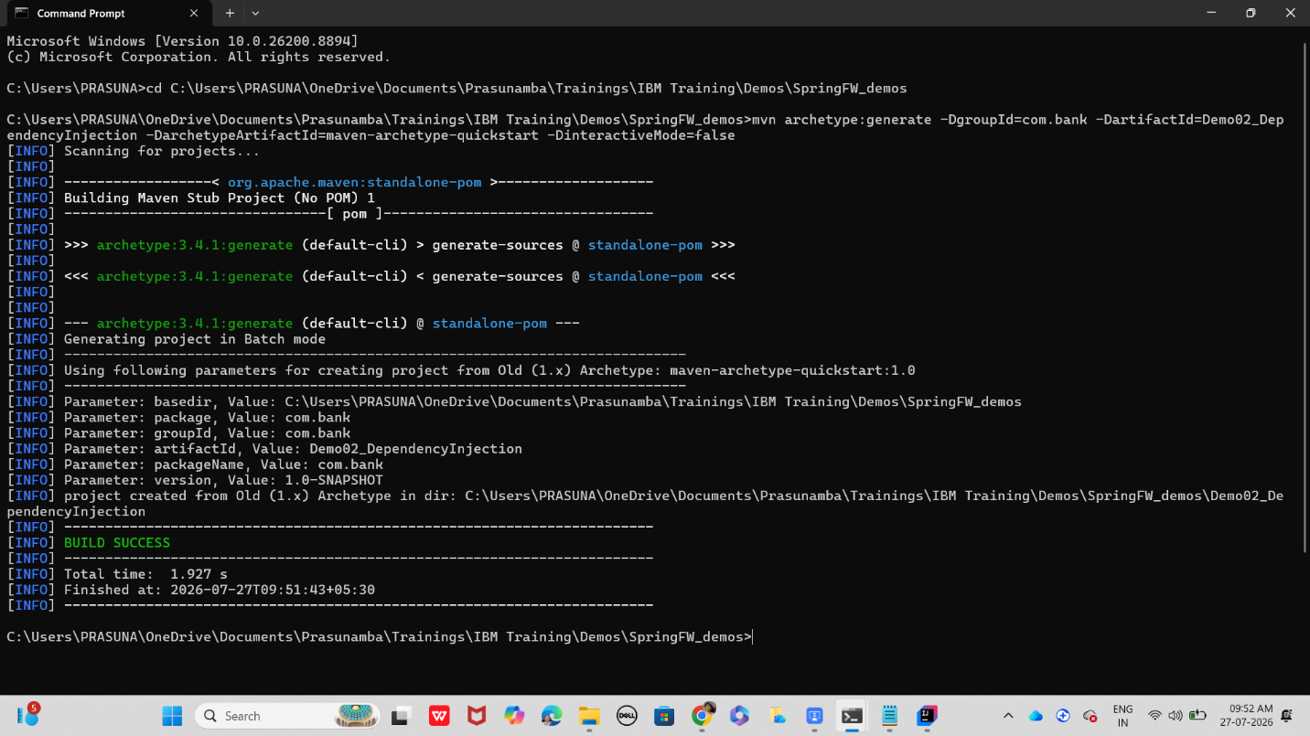

Cd folder name

Project structure
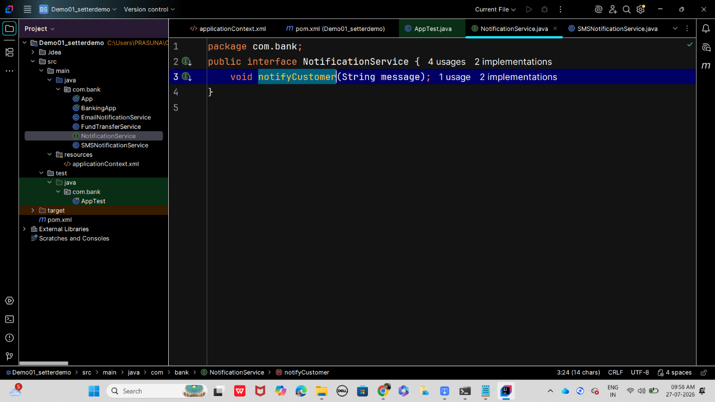

Dependency in [pom.xml

<dependency>
<groupId>org.springframework</groupId>
<artifactId>spring-context</artifactId>
<version>6.1.2</version>
</dependency>

App.java

package com.bank;

import org.springframework.context.ApplicationContext;
import org.springframework.context.support.ClassPathXmlApplicationContext;

public class App {
public static void main(String[] args) {
// Load Spring configuration from applicationContext.xml
ApplicationContext context = new ClassPathXmlApplicationContext("applicationContext.xml");

// Get FundTransferService bean
FundTransferService service = context.getBean(FundTransferService.class);

// Perform a demo transfer
service.transferFunds("ACC123", "ACC456", 5000.0);
}
}

bankingApp.java
package com.bank;
import org.springframework.context.ApplicationContext;
import org.springframework.context.support.ClassPathXmlApplicationContext;

public class BankingApp {
public static void main(String[] args) {
ApplicationContext context = new ClassPathXmlApplicationContext("applicationContext.xml");
FundTransferService service = context.getBean(FundTransferService.class);
service.transferFunds("ACC123", "ACC456", 5000.0);
}
}

EmailNotificationService .java

package com.bank;

import org.springframework.stereotype.Service;

@Service
public class EmailNotificationService implements NotificationService {
@Override
public void notifyCustomer(String message) {
System.out.println("Email sent: " + message);
}
}

FundTransferService.java

package com.bank;

import org.springframework.beans.factory.annotation.Autowired;
import org.springframework.stereotype.Component;

@Component
public class FundTransferService {
private final NotificationService notificationService;

@Autowired
public FundTransferService(NotificationService notificationService) {
this.notificationService = notificationService;
}

public void transferFunds(String fromAcc, String toAcc, double amount) {
System.out.println("Transferred " + amount + " from " + fromAcc + " to " + toAcc);
notificationService.notifyCustomer("Transfer of " + amount + " completed.");
}
}

NotificationService.java

package com.bank;
public interface NotificationService {
void notifyCustomer(String message);
}

SMSNotificationService.java
package com.bank;

public class SMSNotificationService implements NotificationService {
@Override
public void notifyCustomer(String message) {
System.out.println("SMS sent: " + message);
}
}

In src/main add resources folder

applicationContext.xml

<beans xmlns="http://www.springframework.org/schema/beans"
xmlns:xsi="http://www.w3.org/2001/XMLSchema-instance"
xsi:schemaLocation="http://www.springframework.org/schema/beans
http://www.springframework.org/schema/beans/spring-beans.xsd">

<!-- Choose implementation -->
<bean id="notificationService" class="com.bank.EmailNotificationService"/>

<!-- Inject dependency -->
<bean id="fundTransferService" class="com.bank.FundTransferService">
<constructor-arg ref="notificationService"/>
</bean>
</beans>

Now
cd setterdemo
Mvnn clean compile
mvn clean install
mvn exec:java -Dexec.mainClass="com.bank.App"

mvn clean install

Task 01:

What do you understand by Spring frame work?
12.17 to 12.20
Framework for building apps
Provides dependency injection , IOC , cross cutting controls

Task 02:

What is spring boot?
12.21 to 12.23
Built on top of the spring framework , makes the job of creating stand alone objects easier

Task 03:

What is the diff b/w spring framework and spring boot?
12.24 to 12.26

Spring boot is built on top of the spring framework it is a further enhancement of it , it more efficient in creating stand along applications

Task 04:

What is Dependency Injection?
12.27 to 12.34

The ability to plug and play dependencies based on need is called dependency injection

Task 05:

create a simple OrderService that depends on a PaymentService. Instead of creating objects manually, inject them.

Interfaces:

paymentService ' ----> credit card or debit card class
and orderservice ---> PaymentService implementation class
package com.example;
import org.springframework.stereotype.Component;
import org.springframework.beans.factory.annotation.Autowired;

@Component
public class OrderService {

private final PaymentService paymentService;

// Spring sees @Autowired and hands this class the DebitCard automatically.
@Autowired
public OrderService(PaymentService paymentService) {
this.paymentService = paymentService;
}

public void placeOrder() {
System.out.println("Order placed!");
paymentService.pay(); // This will use the DebitCard
}
}

package com.example ;

public interface PaymentService {
void pay();
}

Task 06:

—----------------------------------------------------------------------------------------------------------------------------*************************************************************************************************************
Dependency Check, Inner beans and Scopes *************************************************************************************************************
—---------------------------------------------------------------------------------------------------------------------------

In cmd move to projects folder

mvn archetype:generate -DgroupId=com.bank -DartifactId=DependencyChk_InrBns_BnsScop -DarchetypeArtifactId=maven-archetype-quickstart -DinteractiveMode=false

Dependency check : spring can validate weather req props are set or not
Bank account.java

package com.bank;

public class BankAccount {
private int accountId;
private String accountHolder;

public void setAccountId(int accountId) { this.accountId = accountId; }
public void setAccountHolder(String accountHolder) { this.accountHolder = accountHolder; }

public void display() {
System.out.println("Account ID: " + accountId + ", Holder: " + accountHolder);
}
}

In src/main/ resources

applicationContext.xml

<beans xmlns="http://www.springframework.org/schema/beans"
xmlns:xsi="http://www.w3.org/2001/XMLSchema-instance"
xsi:schemaLocation="
http://www.springframework.org/schema/beans
http://www.springframework.org/schema/beans/spring-beans.xsd">

<!-- Dependency Check ensures accountHolder must be set -->
<bean id="bankAccount" class="com.bank.BankAccount" dependency-check="all">
<property name="accountId" value="101"/>
<property name="accountHolder" value="Prasunamba"/>
</bean>
</beans>

If you remove accountHolder, Spring will throw an error at startup.

Next

Inner Beans
Inner beans are defined inside another bean, useful for one-time use objects.

Customer.java

package com.bank;

public class Customer {
private String name;
private Address address;

public void setName(String name) { this.name = name; }
public void setAddress(Address address) { this.address = address; }

public void display() {
System.out.println("Customer: " + name + ", Address: " + address.getCity());
}
}

Address.java

package com.bank;

public class Address {
private String city;

public void setCity(String city) { this.city = city; }
public String getCity() { return city; }
}

In appContext.xml file ADD
One more bean

<bean id="customer" class="com.bank.Customer">
<property name="name" value="Prasunamba"/>
<property name="address">
<!-- Inner bean -->
<bean class="com.bank.Address">
<property name="city" value="Bengaluru"/>
</bean>
</property>
</bean>

Bean Scopes
Spring supports different bean scopes: singleton, prototype, request, session, application.

In appcontext.xml

Add
<!-- Singleton scope: same instance every time -->
<bean id="singletonAccount" class="com.bank.BankAccount" scope="singleton">
<property name="accountId" value="201"/>
<property name="accountHolder" value="Singleton User"/>
</bean>

<!-- Prototype scope: new instance each time -->
<bean id="prototypeAccount" class="com.bank.BankAccount" scope="prototype">
<property name="accountId" value="202"/>
<property name="accountHolder" value="Prototype User"/>
</bean>

In app.java

package com.bank;

import org.springframework.context.ApplicationContext;
import org.springframework.context.support.ClassPathXmlApplicationContext;

public class App {
public static void main(String[] args) {
ApplicationContext context = new ClassPathXmlApplicationContext("applicationContext.xml");

// Dependency Check demo
BankAccount account = (BankAccount) context.getBean("bankAccount");
account.display();

// Inner Bean demo
Customer customer = (Customer) context.getBean("customer");
customer.display();

// Scope demo
BankAccount acc1 = (BankAccount) context.getBean("singletonAccount");
BankAccount acc2 = (BankAccount) context.getBean("singletonAccount");
System.out.println("Singleton same object? " + (acc1 == acc2));

BankAccount acc3 = (BankAccount) context.getBean("prototypeAccount");
BankAccount acc4 = (BankAccount) context.getBean("prototypeAccount");
System.out.println("Prototype same object? " + (acc3 == acc4));
}
}

mvn clean install
mvn exec:java -Dexec.mainClass="com.bank.App"

Task 7 : UML diagram for banking application
